
Tiankuo Server
I620-G20

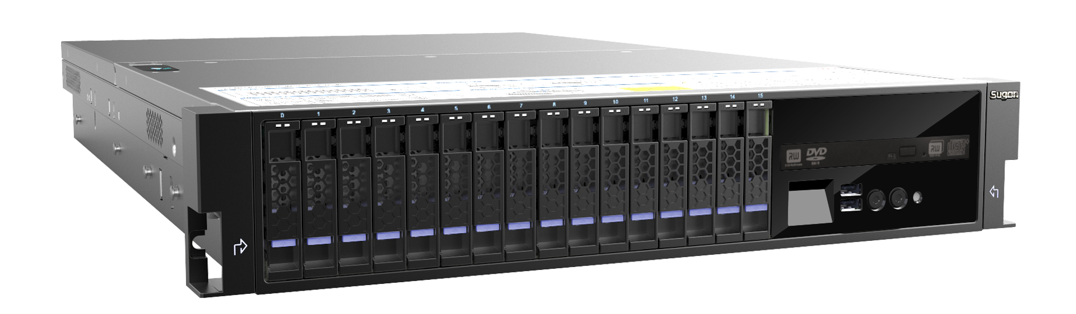

Tiankuo I620-G20 server is a high-performance 2-way server developed by Sugon based on the latest Intel Grantey platform； it can maximum support a memory capacity of 1.5TB；high-performance SAS controller can be integrated. It supports maximum 12 hot-swap 3.5" SAS/SATA HDDs or 24 hot-plug 2.5" SAS/SATA HDDs, 4 2.5 "hot-plug disks can be placed behind. The internal horizontal slot design can meet the demands of full-height expansion cards, which is enough to support the operation of critical tasks, meeting the demands of resource-intensive applications. More PCI-E slots, more efficient PCI-E buses enable users to realize expansion easily. The product is quite suitable for industrial data centers and remote enterprise environments, which have harsh requirements for server performance, expansibility and reliability, such as finance, securities, transportation, post, telecommunications, resources and other industries.

- Features:
- New process architecture brings advanced performance
- Complete modular design, on-demand configurations
- True reliability and availability at an enterprise level
- IO expansion capability
- Horizontal card design supports full-height expansion cards
Overview
New processor architecture
The latest Intel E5-2600V3 series of processors are used to provide higher performance of various applications of users. Compared with products in previous generations, Intel Xeon E5-2600V3 series of processors are given significant improvements, including that the processor can support more cores, DDR4 memory is supported, thus the system performance is greatly improved. More and faster QPI buses are used between processors, thus to significantly improve the cooperation efficiency between CPUs.
Powerful processing performance
The processor integrates 4-way memory controller and supports maximum 2133MHz DDR4 memory; the memory bandwidth performance can be improved by 35%. The latest Intel C610 chip sets are used to support SAS, SAS RAID expansions, thus to provide more options for users.
Rich expansibility
Each CPU is equipped with 12 memory slots, the memory capacity can be expanded to 1.5TB, thus to provide flexible and powerful memory configuration options.
Support 8-28 HDD bays; provide massive storage possibilities for users.
Maximum support 8 I/O expansion slots, PCI-E expansion numbers can be defined, PCI-E 3.0 slots are provided, meanwhile, horizontal slot design is used to satisfy demands of full-height expansion cards, high-performance GPU can be configured.
High density
2U racket design is used, the unique high-density racket server cooling architecture design integrates high performance, high density and high reliability

Technical features

Functional features Advantages
64-bit memory expansion technology
The 64-bit computing capability is able to expand the system application scope, improve computing performance and maintain the compatibility to 32-bit computing
New processor architecture
Compared with products in previous generations, Intel Xeon E5-2600V3 series of processors are given significant improvements, including that the processor can support more cores, DDR4 memory is supported, thus the system performance is greatly improved. More and faster QPI buses are used between processors, thus to significantly improve the cooperation efficiency between CPUs.

DDR 4 memory is used, enhanced RAS memory technology
Support the latest DDR 2133/1866MHz memory, provides higher memory bandwidth and lower memory storage delay, significantly improves the system reliability and availability, completely avoid system downtime caused by memory failures.
Powerful IO expansion performance
Maximum 8 high-speed PCIE 3.0 expansion slots to provide extremely high I/O expansion capability for users, supports various external cards, satisfy demands of users for system functions and performance.

Integrated KVM, easily realize remote management
Provide convenient management for large-scale deployment and remote distributed applications of the server system, permit to visit, install, configure and control remote servers from any place, hardware-level access and control are independent from the operating system, provide complete compatibility, high security, all data transmitted are encrypted.

Hardware-based system monitoring screen
The alarms monitoring screen on the front panel is able to display the server informaiton, CPU temperature, fans velocity, present power and other status of the system, manage interface IP addresses, monitor server states, display disk failures, so that to facilitate the administrator to rapidly find the faulty components and solve that in a timely manner, reduce the downtime losses.

2-section chassis design, enjoy overall increased quality
Multiple options for storage configurations
Newly added humanist design
Integrated casting aluminum chassis
Hidden information card design
Enhanced HDD bay structure
New hot-swap HDD unlocking design
Hidden tools-free lock
Sectioned ends top design
Built in specific maintenance tools
Hanging vibration fans module groups
Indicative paper for easy use of users.
Support 8-bay or 12-bay 3.5 " (compatible to 2.5") hot-swap HDDs
Support 16-bay and 24-bay 2.5" hot-swap disks
Support additional 4 rear hot-swap 2.5" built-in disks to provide more flexible options to users, the built in system disks can be connected to SAS/SAS RAID controller to realize redundant backups.

Technical specifications
Host performance
Processor | Support Intel Xeon E5-2600V3 series of multi-core processors, high-speed QPI connected buses (9.6/8.0/6.4 GT/s, varies according to different CPU models), large-capacity 3-level cache ((15/20/25/30/35 MB，varies according to different CPU models)
Chipset | Intel C610 chip sets
Memory | 24 memory slots  Support DDR4 2133/1866 ECC memory (Working frequency changes according to different CPU and memory configurations)  Maximum expansion memory: 1.5TB
Network controller module | Network interfaces such as integrated double-port RJ45 gigabit, double-port RJ45 10-gigabit, four-port RJ45 gigabit and double-port optional 10-gigabit.
PCI I/O expansion module | Maximum 8 PCI-E expansion slots can be supported  Optional to install high-performance GPU (needs to be coupled with high-power power supplies)
Storage controller | Integrated 8-port SATA HDD controllers, supports RAID 0、1、5  Optional to integrated 8-port SAS card, supports RAID 0/1  Optional to integrated 8-port SAS/RAID card, supports RAID 0/1/5/6
Disk solutions | Four types of units corresponding to 4 types of optional HDD solutions:  8-bay unit can maximum support 8 3.5" or 2.5" hot-plug SAS/SATA HDDs  16-bay unit can maximum support 16 2.5" hot-plug SAS/SATA HDDs  12-bay unit can maximum support 12 3.5" or 2.5" hot-plug SAS/SATA HDDs  24-bay unit can maximum support 24 3.5" or 2.5" hot-plug SAS/SATA HDDs  All types of units support mixed inserted SAS/SATA HDDs, meanwhile, support to choose 4 rear hot-plug 2.5” SATA/SAS disks or SSD disks
Other ports | 1 RJ-45 management interfaces behind the chassis  4 USB 3.0 interfaces, 2 behind the chassis and 2 in front of the chassis  1 VGA interface behind the chassis, front can be supported by option  1 serial behind the chassis
Power supply | 550W CRPS high-efficiency platinum power supplies can be additionally configured to 1+1 redundancy  Optional to support GPU independently powered 1200W high-power redundant power supplies
Cooling | 4 high-speed system fans in default configurations
Management function | Integrated BMC chips, support IPMI2.0 and KVM Over IP senior management function
CD-ROM | Optional to DVD-RW built in SATA drivers
Monitoring screen | 8/16-bay unit can select double-key LCM monitoring screen  12-baby or 24-bay units do not support LCM monitoring screens.
Graphics card | Integrated display controller, 16MB display memory
Operating systems supported | Windows Server 2008 Enterprise Edition R2 SP164bit  Windows Server 2012 Enterprise Edition  Red hat Enterprise Linux 6.2 for Intel EM64T  Red hat Enterprise Linux 6.3 for Intel EM64T  Red hat Enterprise Linux 6.5 for Intel EM64T  Red hat Enterprise Linux 7 for Intel EM64T  SuSE Linux Enterprise Server 12 for Intel EM64T  In case of any change in the operating systems supported, no further notification will be released.
Power voltage | 200-240V/50Hz
Chassis | 2U racket server chassis
Chassis dimensions | 87.8mm(H) x 448mm(W) x775.6mm (D)
Weight | Maximum 35kg (excluding the slide rails)
Requirements for environment temperature | For work:10℃～35℃(50℉～95℉)  For storage:-40℃～55℃(-40℉～131℉)
Requirements for relative humidity | Maximum relative humidity in work:90％RH（40℃）  For work:35％～80％ RH  For storage and transport:20％～93％ RH
Vibration | Frequency:5Hz～150Hz, acceleration≤20m/s2 ,amplitude:≤0.15mm
Impact | Peak acceleration 150m/s2～300m/s2, duration≤11ms
Collision | Peak acceleration:100m/s2～150m/s2, times: not more than 1000 times

For more information:
Please visit official Sugon website: www. Sugon.com or dial the customer service hot line: 400-810-0466
You can also contact Sugon branches distributed throughout the state, for contact information, please log in the official website of Sugon.
Sugon reserves the right modify the product specifications or other product information (including, but not limited to weights, appearance, dimensions or other physical elements) without any further notification.
Any alternation to information involved in the document caused by products upgrading or other causes, no additional notification will be provided. All product graphics involved in the document shall be subject to the physical products.

